Exploratory Data Analysis

4.1 Distribution of type of Store with respect to Weekly Sales
Below chart indicates the box plot of store type and weekly sales.
We can observe that the median of each type of store decreases from A store to C.

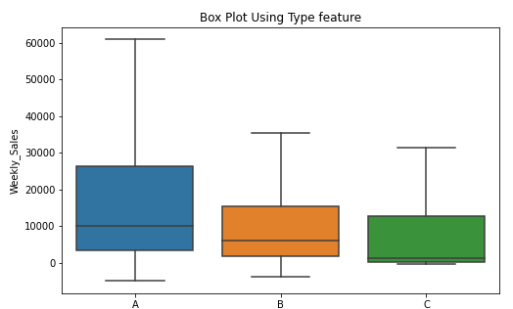

4.2 Distribution of Weekly Sales across Each Department
The Plot below shows the details about department name. Size shows sum of weekly sales. The marks are labelled by department number

4.3 Distribution of Sales across Each Store
Sum of weekly sales for each store. Colour shows details about store.
Store 20 has highest sales and least sales is in store 33.

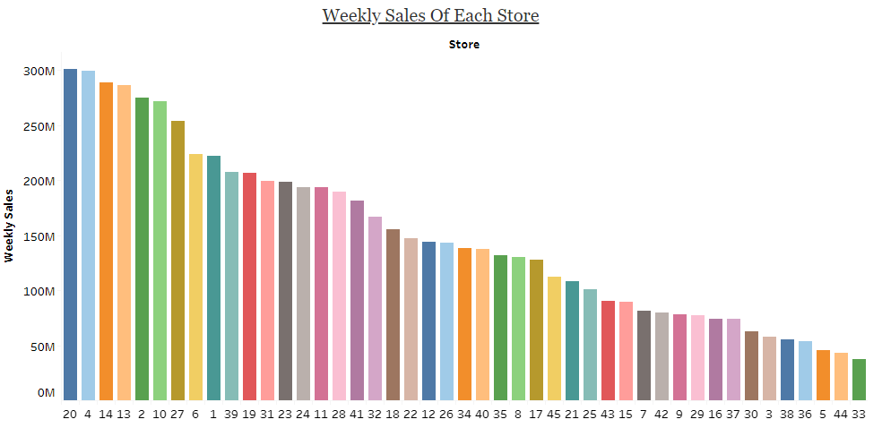

4.4 Distribution of Weekly Sales across Years
The graph below represents the trend of sum of weekly sales for month broken down by year. The marks are labelled by sum of weekly sales.
Comparatively, the sales are high in the year of 2010 December and least sales are in the year of 2011 January.

4.5 Distribution of Sales across Weeks
Plot representing the distribution of average of weekly sales for each week.
Week 52 has highest sales because it falls under the week of Christmas followed by Week6, Week7 as Superbowl etc...

4.6 Distribution of Stores across Store Type
Plot representing the distinct count of store for each type. Colour shows details about type.
Type A has a greater number of stores (22)

4.6 Distribution of Sales across Store Type
Plot representing the type (colour) and sum of weekly sales (size).
Type A has highest sales
Type C has least sales

4.7 Distribution of Weekly sales for each Fuel Price
Plot representing the distribution of average of weekly sales for each fuel price.

4.8 Distribution of weekly sales
Weekly Sales is positively skewed indicating few large values. This could be caused by the festive Weeks.

4.9 Distribution of weekly sales after doing log transformation
We have transformed it using a log transformation as can be seem from the plot below which will be required when we build the model.

4.11 Store Size vs Sales
There is a linear relation between store size and weekly sales.

